**1.What is Deep learning**

* Deep learning is a subset of  [machine learning](https://www.ibm.com/topics/machine-learning) that uses multilayered [neural networks](https://www.ibm.com/topics/neural-networks), called deep neural networks, to simulate the complex decision-making power of the human brain. Some form of deep learning powers most of the [artificial intelligence (AI)](https://www.ibm.com/topics/artificial-intelligence) applications in our lives today.
* Deep learning is an [artificial intelligence (AI)](https://aws.amazon.com/what-is/artificial-intelligence/) methodthat teaches computers to process data in a way inspired by the human brain. Deep learning models can recognize complex pictures, text, sounds, and other data patterns to produce accurate insights and predictions. You can use deep learning methods to automate tasks that typically require human intelligence, such as describing images or transcribing a sound file into text.

**2.What is Neural Network and its types**

* A neural network, or artificial neural network, is a type of computing architecture that is based on a model of how a human brain functions — hence the name "neural." Neural networks are made up of a collection of processing units called "nodes." These nodes pass data to each other, just like how in a brain, neurons pass electrical impulses to each other.
* Neural networks are used in machine learning, which refers to a category of computer programs that learn without definite instructions. Specifically, neural networks are used in deep learning   an advanced type of machine learning that can draw conclusions from un labelled data without human intervention. For instance, a deep learning model built on a neural network and fed sufficient training data could be able to identify items in a photo it has never seen before.

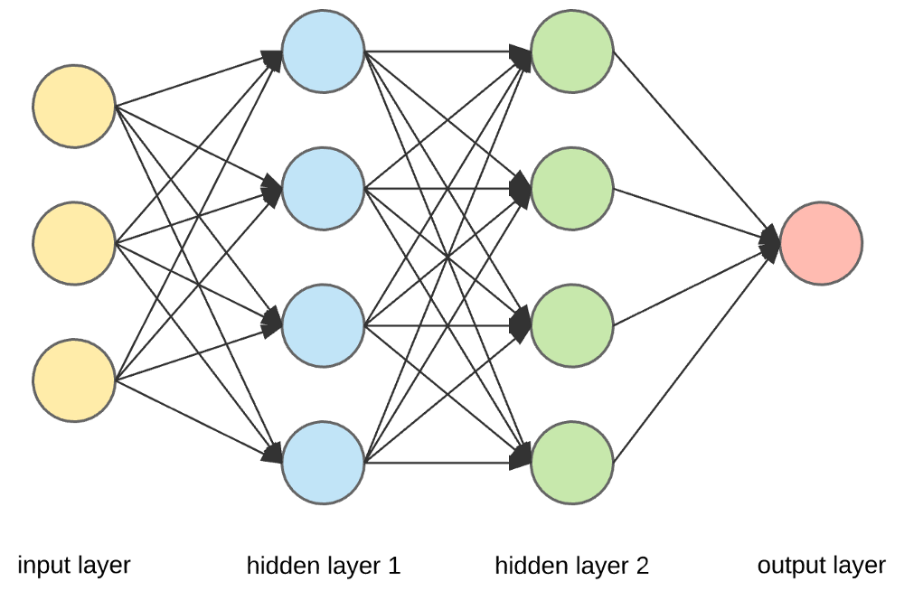

“Example of Neural Network “

Types:

* **Convolutional neural networks**

Convolutional neural networks (CNNs) can input images, identify the objects in a picture, and differentiate them from one another. Their real-world applications include pattern recognition, image recognition, and object detection. A CNN’s structure consists of three main layers. First is the convolutional layer, where most of the computation occurs. Second is the pooling layer, where the number of parameters in the input is reduced. Lastly, the fully connected layer classifies the features extracted from the previous layers.

* **Recurrent neural networks**

Recurrent neural networks (RNNs) can translate language, speech recognition, natural language processing, and image captioning. Examples of products using RNNs include smart home technologies and voice command features on mobile phones. Feedback loops in the structure of RNNs allow information to be stored similarly to how your memory works.

**3.What is CNN**

CNN = Convolutional neural networks

* A convolutional neural network (CNN) is a category of machine learning model. Specifically, it is a type of deep learning algorithm that is well suited to analyzing visual data. CNNs are commonly used to process image and video tasks. And, because CNNs are so effective at identifying objects, they are frequently used for computer vision tasks, such as image recognition and object recognition, with common use cases including self-driving cars, facial recognition and medical image analysis
* CNN architecture is inspired by the connectivity patterns of the human brain -- in particular, the visual cortex, which plays an essential role in perceiving and processing visual stimuli

**4.Project Pipelines**

* **Data collection and Data loading**
* A data collection pipeline is a series of processes that automate the flow of data from its source to a destination for analysis or storage. It involves collecting, transforming, and delivering data, often from multiple sources, in a structured and reliable manner.
* A data pipeline is a method in which raw data is ingested from various data sources, transformed and then ported to a data store, such as a data lake and others for analysis.
* For this project we are getting Database for this project from Kaggle.com website link = <https://www.kaggle.com/datasets/elmadafri/the-wildfire-dataset> this is the link where we will we getting and accessing our dataset for this Project
* **Image Processing and Image Augmentation**
* An image processing pipeline is a sequence of operations performed on an image, from its capture or creation to its final display or use This pipeline typically involves multiple stages, including image acquisition, preprocessing, enhancement, restoration, and compression, all culminating in the desired output
* Image Segmentation divides an image into segments where each pixel in the image is mapped to an object. This task has multiple variants such as instance segmentation, panoptic segmentation and semantic segmentation.